**Assignment No.1**

1. **Install Git on your machine if it is not already installed.**

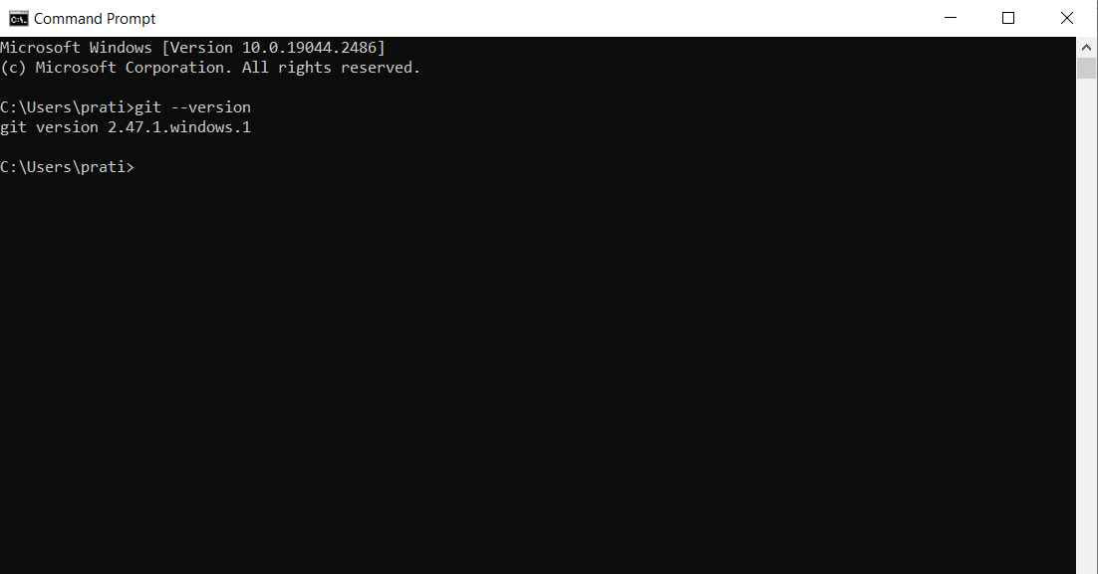

1. **Initialize a new Git repository for the finance application.**

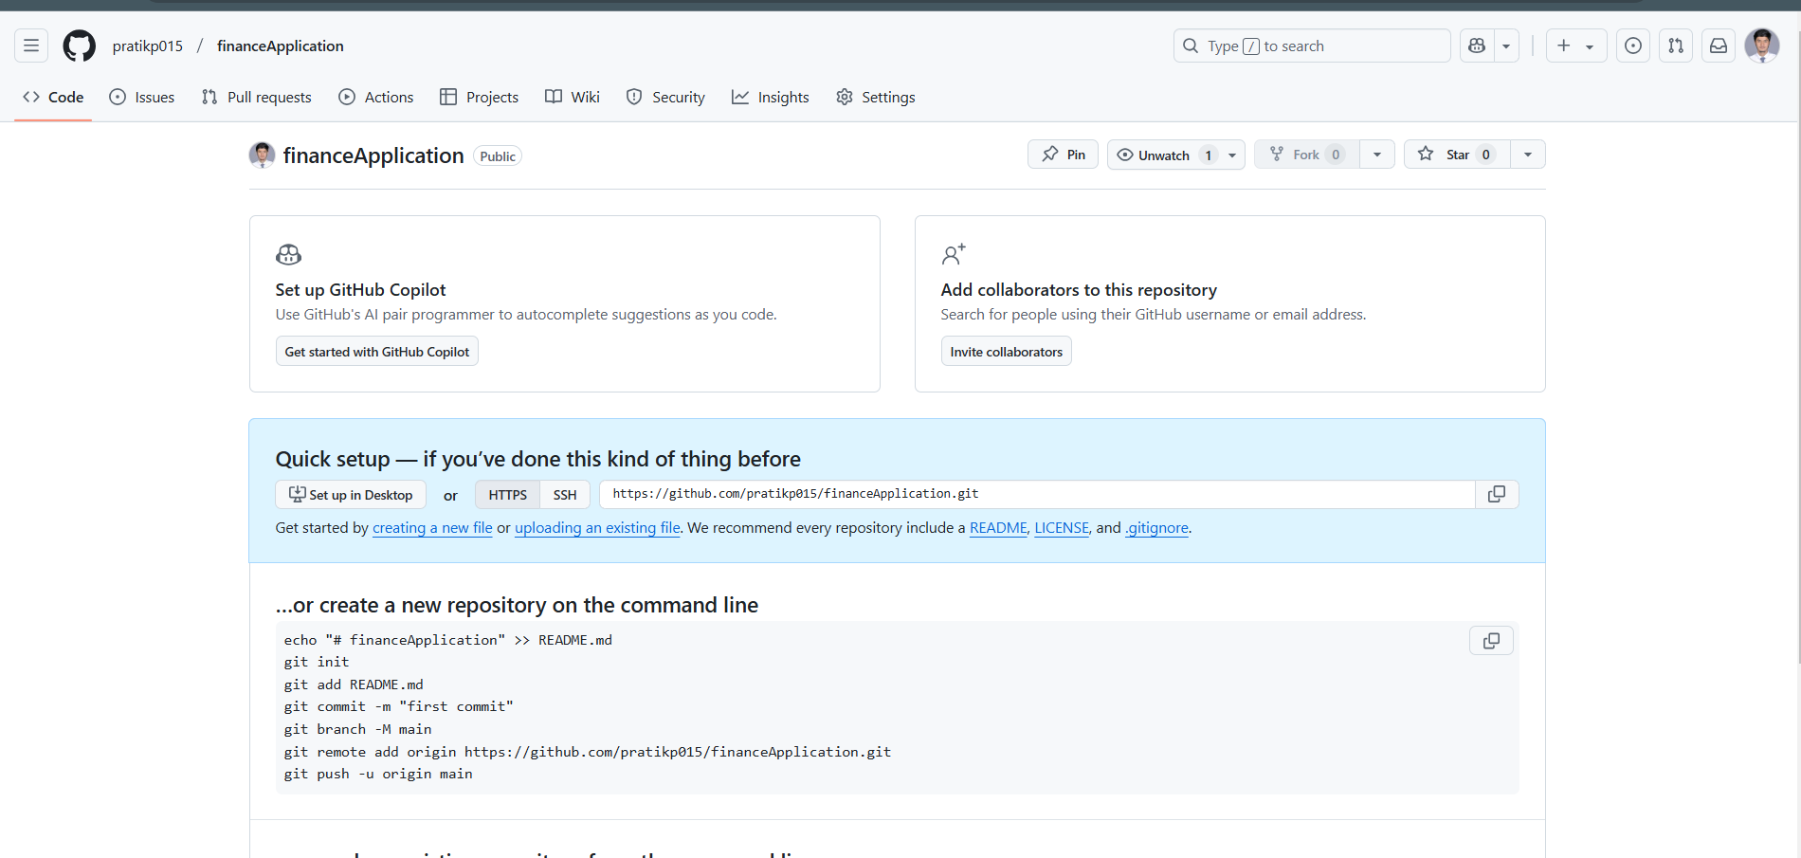

1. **Create a .gitignore file and configure it to ignore unnecessary files (e.g., .env,**

**node_modules).**

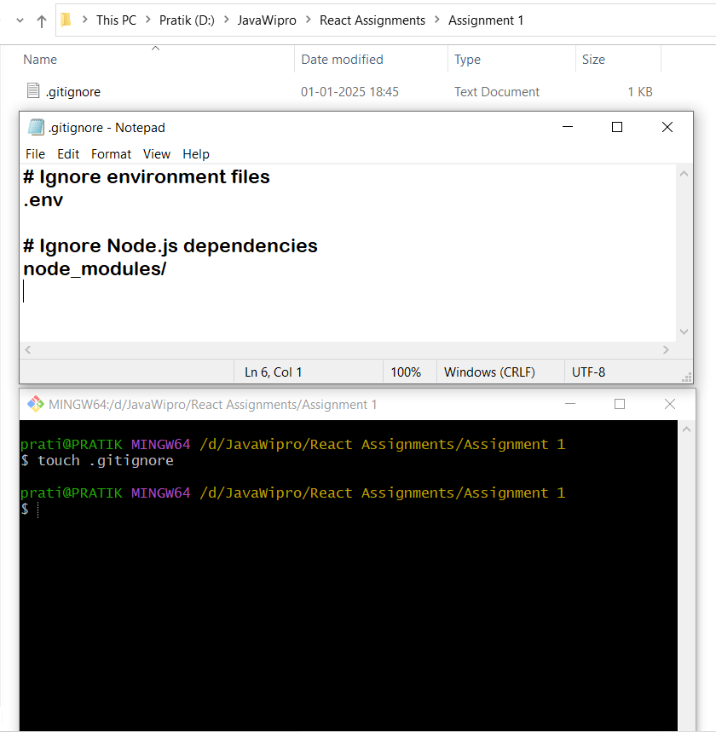

1. **Add a README.md file with the project name and description.**

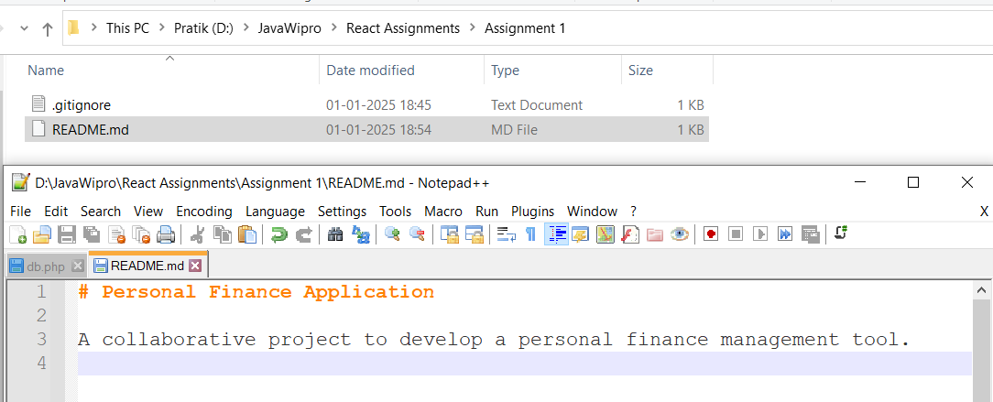

1. **Configure the repository user name and email.**

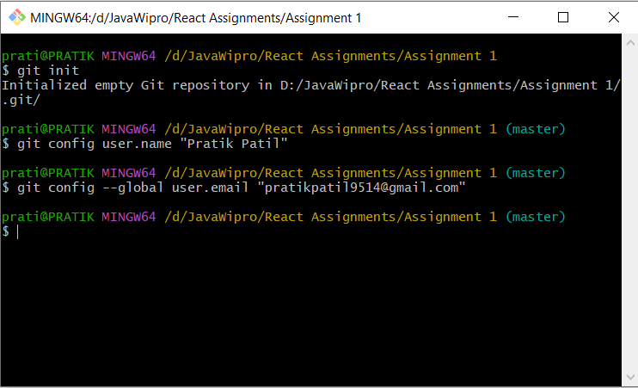

1. **Stage and commit all files with the message &quot;Initial project setup.&quot;**

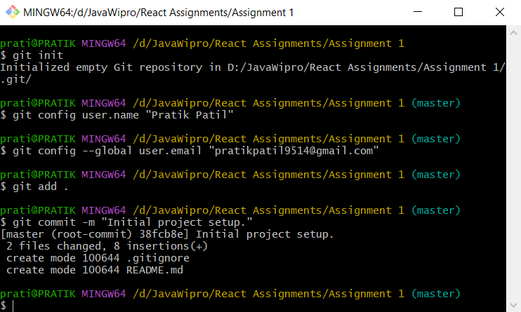

1. **Verify the repository state using Git status and log commands.**

